What is Continuous Integration?
- Developers commit code to a shared repository on a regular basis
- Version control system is being monitored. When a commit is detected, a build will be triggered automatically.
- If the build is not green, developers will be notified immediately.

from above Diagram,
- Automated builds are scheduled on a regular basis.
- Build script compiles the application and runs a set of automated tests.
- Developers now commit their changes regularly.
- A build is triggered whenever new code is committed to the central repository.
- Build servers would alert the team members in case of build failure.
- Broken builds are usually treated as a high priority issue and are fixed quickly.

Continuous Integration
The practice of merging development work with the main branch constantly.

Continuous Delivery
Continual delivery of code to an environment once the code is ready to ship. This could be staging or production. The idea is the product is delivered to a user base, which can be QAs or customers for review and inspection.
Continuous Deployment
The deployment or release of code to production as soon as it is ready.

What is Jenkins
- Jenkins is a continuous integration and build server.
- It is used to manually, periodically, or automatically build software development projects.
- It is an open source Continuous Integration tool written in Java.
- Jenkins is used by teams of all different sizes, for projects with various languages.
Features
- Easy to use
- Support different version control systems
- Code quality metrics
- Build notifiers
- UI customization

Intsalling Jenkins
- Check Java 8 (either a JRE or Java Development Kit (JDK) is fine)
- Download Jenkins.
- Open up a terminal in the download directory.
- Run java -jar jenkins.war --httpPort=8181, Copy the code from commandline
*************************************************************

Jenkins initial setup is required. lease use the following password to proceed to installation:

2d4dd377b9d34f36adfc23f1e4a60d9f

This may also be found at: C:\Users\satya\.jenkins\secrets\initialAdminPassword

*************************************************************

- Browse to http://localhost:8181, paste the code
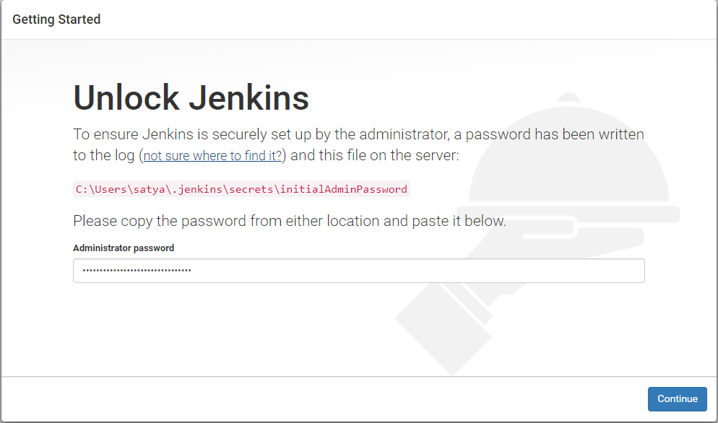

- Follow the instructions to complete the installation.

For java 10.x use
java --add-modules java.xml.bind -jar jenkins.war --enable-future-java --httpPort=8080 --prefix=/jenkins

Jenkins Dashbaord

Let's understand the dashboard parameters:
- New Item: To create new build job, pipeline or build flow in Jenkins 2.
- Manage Jenkins: Allows Jenkins 2 administrator to manage plugins, users, security, nodes, credentials, global tools configuration and so on.
- To know about existing nodes that are used for build execution, click on Manage Nodes. master node entry will be available. It is the node where Jenkins is installed. We can add multiple slave node to distribute the load.

Jenkins Configuration

Change Jenkins PORT number
Some times 8080 is busy with some other services. In that case we can change port to some other number by using following steps
1.Press Ctrl+C on Jenkins command line to Stop the Service
2.It it is Jenkins.war Installation, Start Jenkins from cmd line using :
java -jar jenkins.war --httpPort=8081
3.If is tomcat Installation, open xml & change "--httpPort=8080" with new port number

Configuring Java
1.Navigate to Manage Jenkins → Global Tool Configuration→JDK Installations →Add JDK
2.Set JDK Name. For Ex: JDK_1.8.0_111 (uncheck Install automatically)
3.Set JAVA_HOME directory path. For Ex: C:\Program Files\Java\jdk 1.8.0_111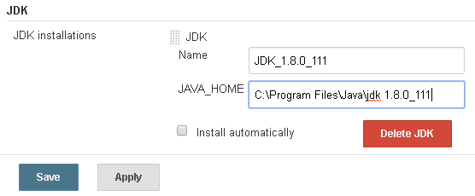
4.Apply & Save.

Configuring Maven
1.Navigate to Manage Jenkinks→ Global Tool Configuration→ Maven Installations→ Add Maven
2.Set Maven Name. For Ex: apache-maven-3.3.9 (uncheck Install automatically)
3.Set MAVEN_HOME directory path. For Ex: C: \apache-maven-3.3.9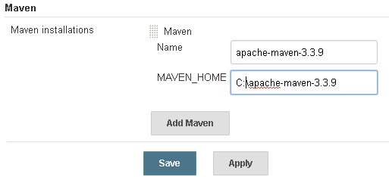
4.Apply & Save

Configuring build job for Java application with Maven

1.Go to Jenkins Dashboard and click on New Item.
- Enter an item name such as PetClinic.
- Select Freestyle project.
- Click on OK.
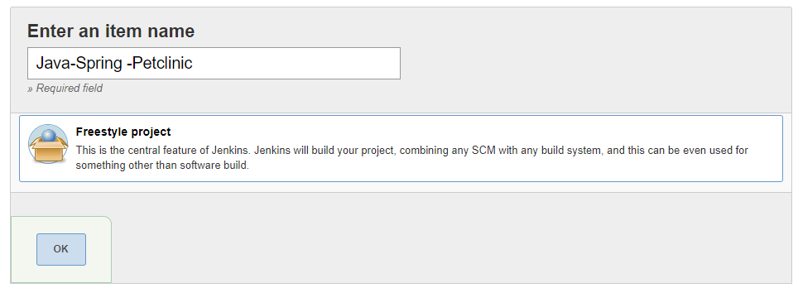
Job is created in this location: C:\Users\satya\.jenkins\jobs\PetClinic

2.Github SSH connection
1.Execute ssh-keygen -t rsa -b 4096 -C "smlcodes@gmail.com" command by substituting in GitHub email address.key generated in C:\Users\satya/.ssh/id_rsa
2. To configure GitHub account to use new SSH key, add it to your GitHub account. Go to https://github.com/smlcodes and click on Settings > SSH and GPG keys > Add SSH : copy id_rsa.pub & paste it here.
3.After that verify the Connection.
satya@DESKTOP-I4LP77B MINGW64 ~
$ ssh -T git@github.com
Are you sure you want to continue connecting (yes/no)? yes
Hi smlcodes! You've successfully authenticated.

3. Configure PetClinic build job.
1. Go to dashboard > Petclinic Project > Configure > Source Code Management : provide github project clone url & Save 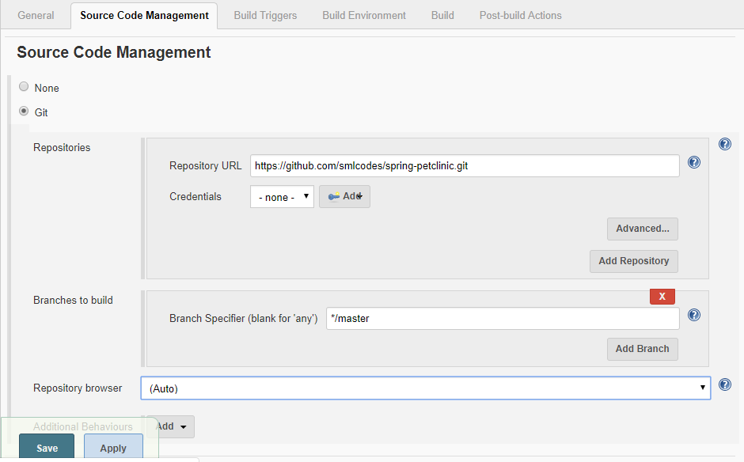
2.Build Triggers, Select : GitHub hook trigger for GITScm polling 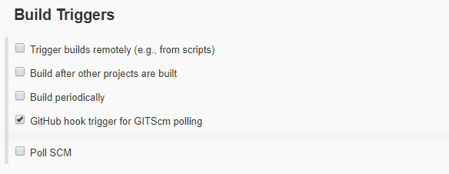
3.Build: Add build step > Invoke top-level maven Targets. 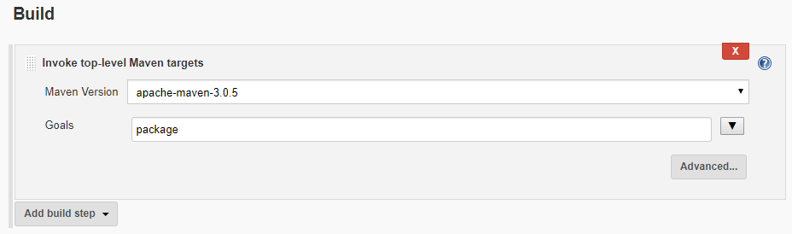
4. Build Now : Save & Trigger the job manually.
5. Once source code is available in the build job's workspace, Maven target will be executed and war file will be created. Verify the build status.
Downloaded: http://repo.maven.apache.org/maven2/org/apache/commons/commons-compress/1.14/commons-compress-1.14.jar (518 KB at 797.5 KB/sec)
[INFO] Building jar: C:\Users\satya\.jenkins\workspace\PetClinic\target\spring-petclinic-2.1.0.BUILD-SNAPSHOT.jar
[INFO]
[INFO] --- spring-boot-maven-plugin:2.1.0.BUILD-SNAPSHOT:repackage (repackage) @ spring-petclinic ---
SLF4J: Failed to load class "org.slf4j.impl.StaticLoggerBinder".
SLF4J: Defaulting to no-operation (NOP) logger implementation
SLF4J: See http://www.slf4j.org/codes.html#StaticLoggerBinder for further details.
[INFO] Replacing main artifact C:\Users\satya\.jenkins\workspace\PetClinic\target\spring-petclinic-2.1.0.BUILD-SNAPSHOT.jar
[INFO] ------------------------------------------------------------------------
[INFO] BUILD SUCCESS
[INFO] ------------------------------------------------------------------------
[INFO] Total time: 19:28.000s
[INFO] Finished at: Sun Oct 14 12:09:45 IST 2018
[INFO] Final Memory: 90M/214M
[INFO] ------------------------------------------------------------------------
Finished: SUCCESS

6. To verify the workspace of a build Job, click on the Workspace link. Verify all the files available in the workspace. We can find these files in .jenkins folder under specific build job (C:\Users\satya\.jenkins\workspace\PetClinic).
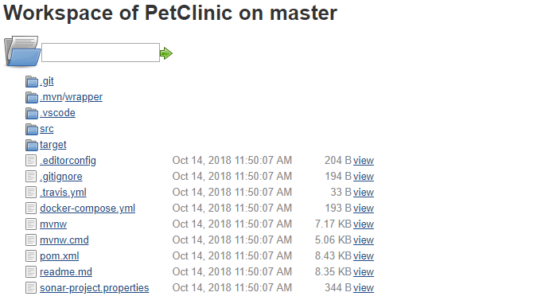
Integrating JUnit
Our sample application has JUnit test cases and to execute them, we need to configure JUnit related settings in build job configuration.
1.In Post-Build Actions, select Publish JUnit test result report.
2.Provide path for Test Report XMLs based on the workspace.
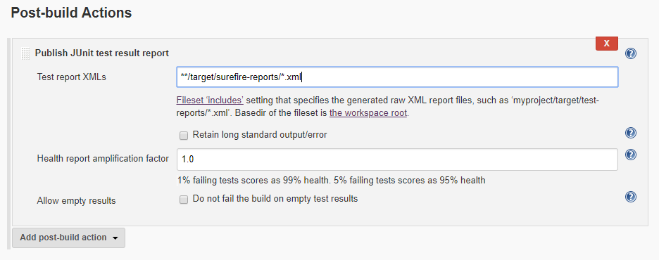
Click on Apply and then click on Save.
3.Once we configure JUnit settings in a build, wait for the build execution based on scheduling or click on the Build Now link.
4.Verify the build status on Jenkins dashboard and you will see Test Result link with small summary. Click on the Test Result link. 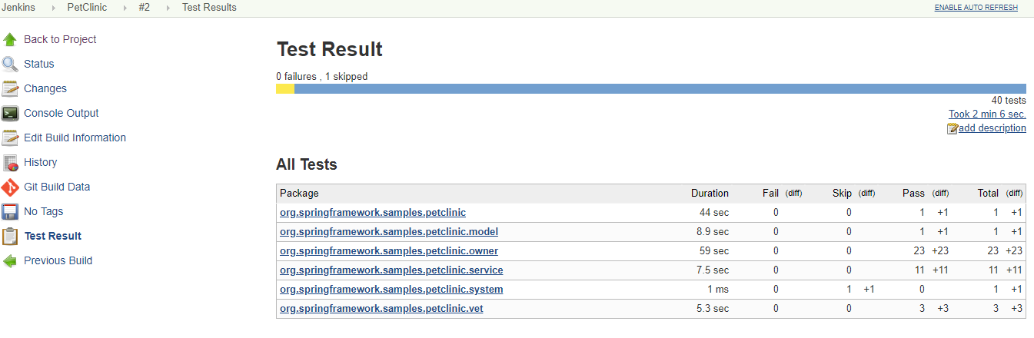

Dashboard view plugin
Dashboard View plugin provides different view implementation considering portal kind of layout. We can select different build jobs to be included in new view and configure different portlets for view.
1.Go to Plugin Manager from Manage Jenkins, and click on the Available Tab. Search for Dashboard View plugin and click Install without restart.
2.Once installation of Dashboard View plugin is completed successfully, we can create a new view by clicking on the + sign on Jenkins dashboard. 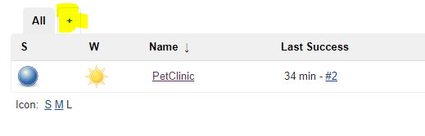
3.Enter View name, select view type and click on OK.

Jenkins’ Master and Slave Architecture

Master:
- Schedule build jobs.
- Dispatch builds to the slaves for the actual job execution.
- Monitor the slaves and record the build results.
- Master node itself can execute the build if slave node is not configured explicitly in the build job configuration

Slave:
- Execute build jobs dispatched by the master.

We don’t need to install Jenkins in the slave nodes. We only need to configure slave node properly.
The only requirements are:
- Configurations and Runtime Environment has to be available on the slave node.
- Path needs to be configured correctly on Master node for Runtime. Environments or tools used by slave node for execution
Creating Slave machine
I am uing vagrant Ubuntu/trusty64 as slave machine
1.we need to upload the key 'id_rsa.pub' from the master to slave server nodes. We need to upload to each server nodes using command as below.
scp id_rsa vagrant@192.168.0.104:~/.ssh
scp id_rsa.pub vagrant@192.168.0.104:~/.ssh

2.Install Java on Slave
Install the 'software-properties-common' packages and add the java PPA repository
sudo add-apt-repository ppa:openjdk-r/ppa
sudo apt-get update
sudo apt-get install openjdk-8-jdk
java -version

3.Install Maven on Slave
apt-cache search maven
sudo apt-get install maven
mvn -version

4.Add Slave node
Dashboard > Manage Jenkins > Manage Nodes > New Node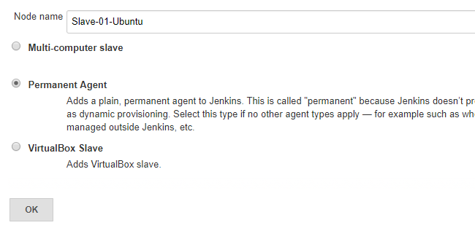
- Name: Slave-01-Ubuntu
- Remote root directory: /home/vagrant
- Launch method: Launch slave agent via SSH, type the host ip address 192.168.0.104
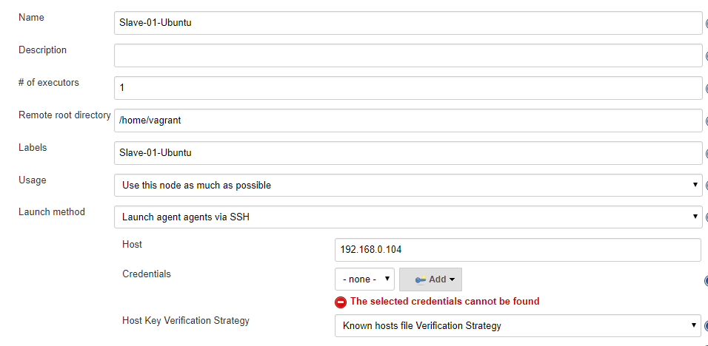
Vagrant-Ubuntu Credentials: Credencials > Add, then select added credencials 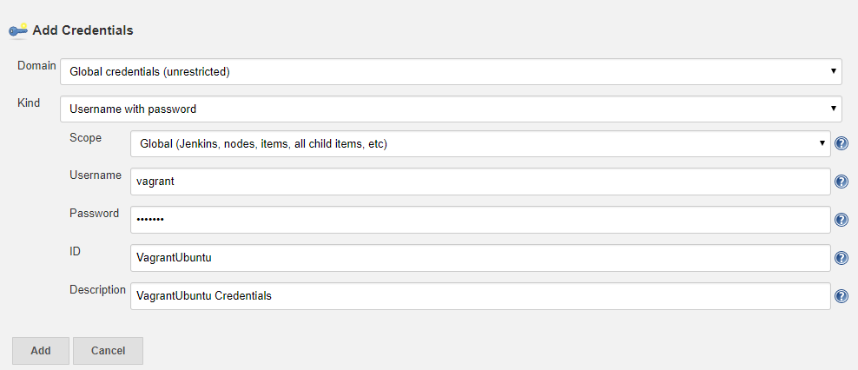

4.Configure Git, Java, Maven locations in Slave Node

To get Locations of Tools in Ubuntu system run below cmds
vagrant@vagrant-ubuntu-trusty-64:~$ which git
/usr/bin/git
vagrant@vagrant-ubuntu-trusty-64:~$ which java
/usr/bin/java
vagrant@vagrant-ubuntu-trusty-64:~$ which mvn
/usr/bin/mvn

Go To Manage Jenkins > Manage Nodes > Select: Slave Node > Configure > Tool Locations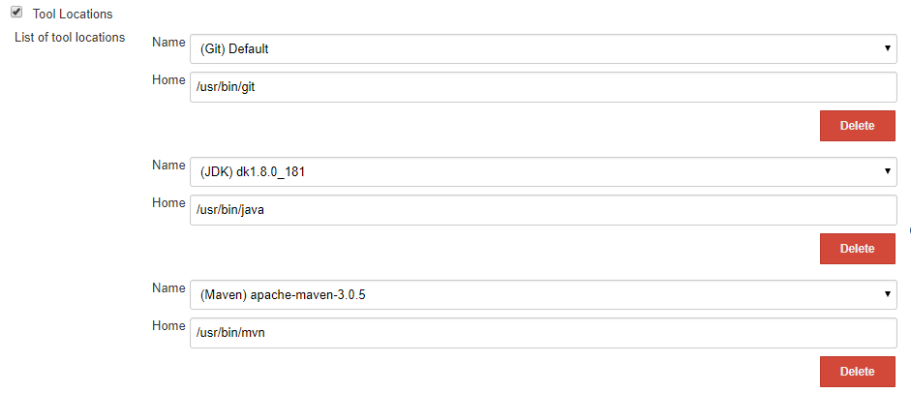
Build the Job.

Jenkins – Setup Email notifications using Gmail
1.Go to https://myaccount.google.com/u/1/lesssecureapps?pli=1 , Allow less secure apps: ON
2.Go to Manage Jenkins > Configure System > E-mail Notification
SMTP server: smtp.gmail.com
Check : Use SMTP Authentication
Enter : Gmail Id / Password
Check : Use SSL
SMTP Port : 465
Check : Test configuration by sending test e-mail
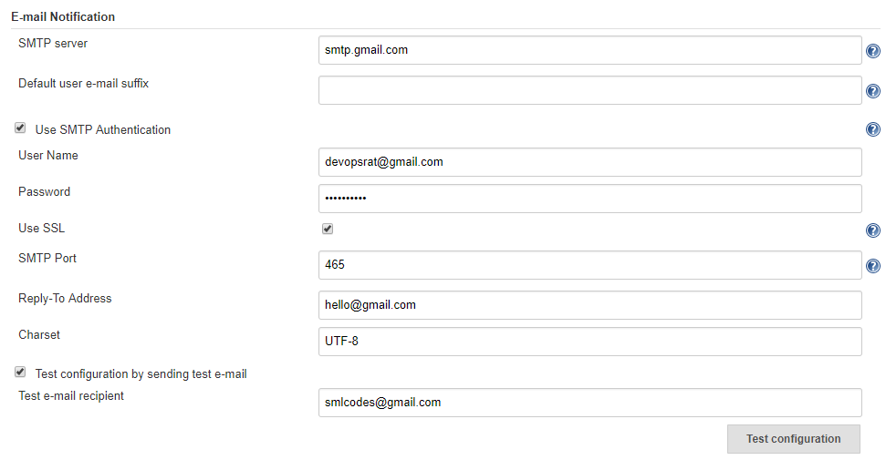
3.So now, we will configure how to send email notification, if build got failed! Follow me!
4. Open any build job and click on Configure > Post-build Actions > Add post-build action > Select: E-mail Notification > Enter list of Recipients. 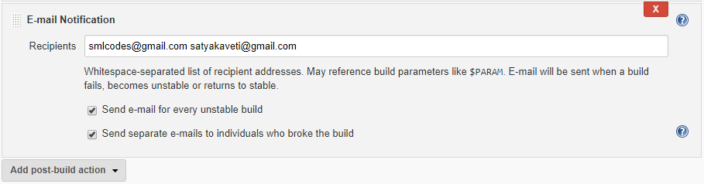

Jenkins – Jenkins and SonarQube Integration
SonarQube is an open source tool to manage code quality of an application. It manages seven axes of code quality such as Architecture & Design, Duplications, Unit Tests, Potential Bugs, Complexities, Coding Rules, and Comments.
It covers many programming languages such Java, JavaScript, JSON, Objective-C, PHP, PL/I, PL/SQL, Puppet, Python, RPG, Swift, VB.NET, Visual Basic 6, Web, and XML etc.

Installing SonarQube
1.Download sonar from http://www.sonarqube.org/downloads/
2. Extract installable directory from the zip file and go to bin sub-directory.
3. Based on the operating system, select the installable directory and run the StartSonar.bat
4.Once Sonar is up and running, Open browser and visit http://localhost:9000/ or http://<IP_Address>:9000/ . We will get the Sonar dashboard.
5.For Jenkins and Sonar integration security token is required.
6.To generate Token SonarQube Dashboard > Top Right Corner > MyAccount >Security >Generate Token & Copy the Token, we will use in Jenkins
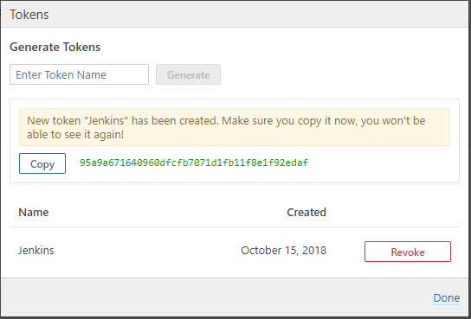

Jenkins & Sonar Integration
1.Manage Jenkins > Manage Plugins > Search : SonarQue , Install with out restart 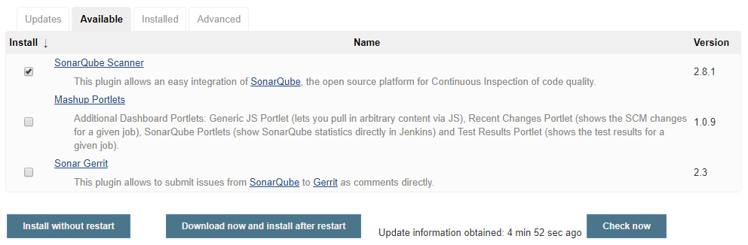

2.Now we have to add SonarQube Severs, for that go to Manage Jenkins > Configure System > add SonarQube Severs: provide Sonar Details & Token
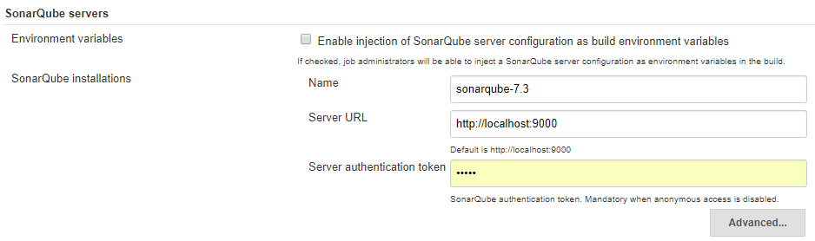
3. In Global Tool Configuration, configure SonarQube Scanner installations also. 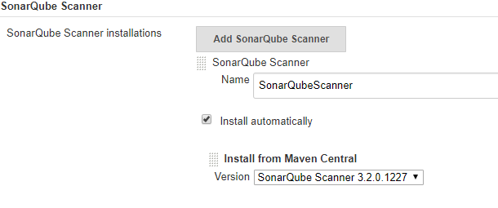
4. Once all Sonar related installations and configurations are completed, we need to add Build step to execute SonarQube Scanner. Just add below Step, no need to configure anything, leave it as it is.
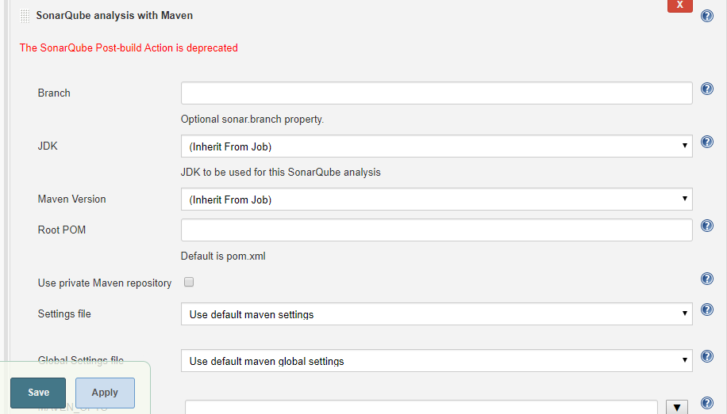
5.Make sure sonar-project. properties file is avaible in your project 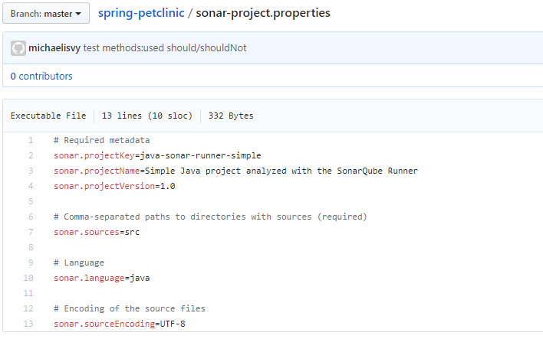

6.Build the Job, onec Job completed, check Sonar UI
http://localhost:9000/dashboard?id=org.springframework.samples%3Aspring-petclinic
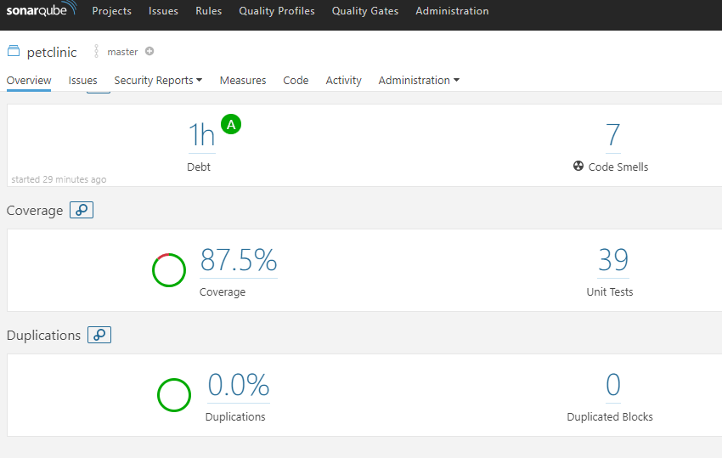

Errors and Solutions
SHA-512 based signature in the update center doesn't match with the certificate in 'update site 'default''?
- Are you using Java 10.X version, change to Java 1.8
- Check cmdline log, it throws error, if Java 10 is not suppotted with installed Jenkins.

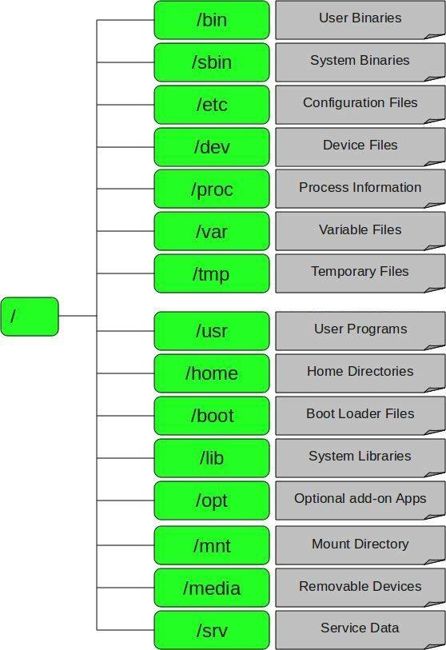

References
https://www.howtoforge.com/tutorial/ubuntu-jenkins-master-slave/

